Assisted Practice 24 Name: Prajwal Diwakar

XML and XML Schema Assertion.

XML Assertion:

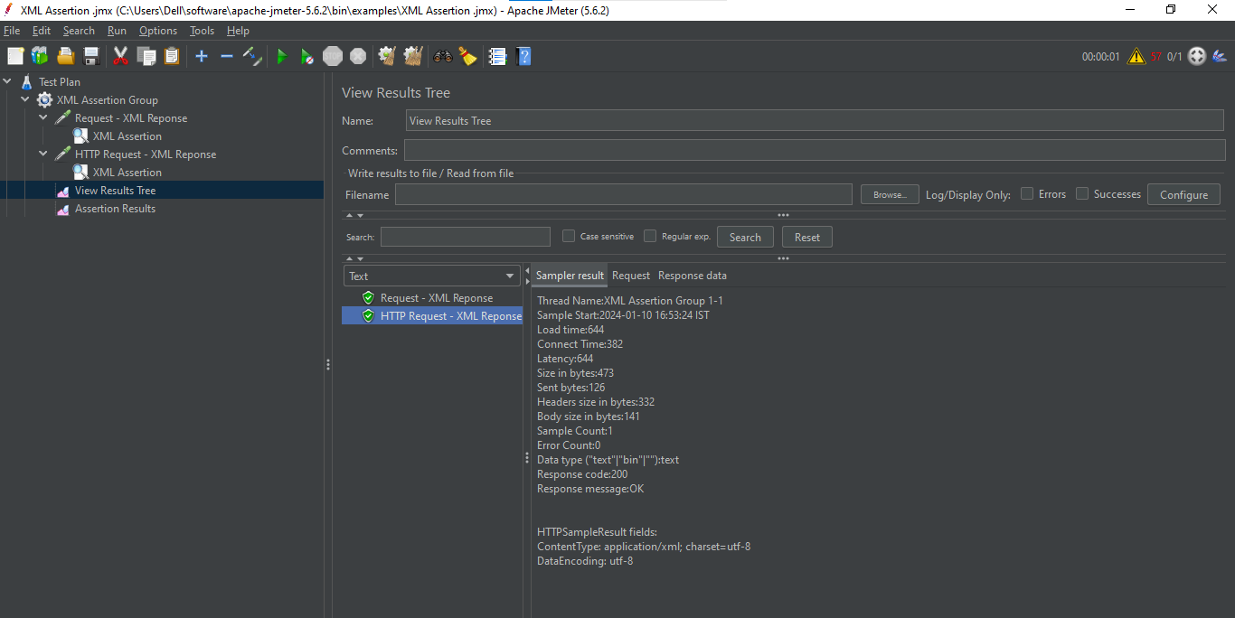

XML schema Assertion:

